How to create a Miscellaneous booking in DOTW?
A miscellaneous booking is used by WebBeds staff to make a manual booking in DOTWConnect, based on rates and availability that are manually coordinated or taken from a hotel or supplier. A miscellaneous booking can be done for any service that a WebBeds user is unable to book online via the New Booking Function or unable to amend using the Amend Booking or Amend Offline function.

Lastly, the Miscellaneous booking can be used for Accommodation, Transfer and Tour bookings. The same process of creating a miscellaneous booking applies to all services.

To create a MISCELLANEOUS Booking, a user would need to click on the MISC link in the Operations section. This will pull down a drop-down list, showing the available services to book. The team member would need to click on BOOKINGS.

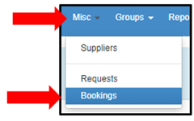

This will load the next page, where the customer’s profile would need to be input. To do this, the user would need to encode the client’s name in the COMPANY NAME field and choose the correct customer profile from the list of the customers that would pop up. Afterwards, the user would need to indicate how many units of the Miscellaneous booking needs to be created.

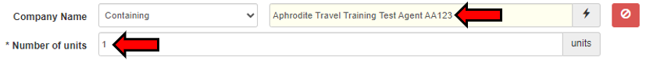

Once the correct profile is found, the user can now click on the FILTER CUSTOMERS button. Doing this would allow a user to see all the DOTWConnect user profiles the client has with us. Clients would usually have multiple user profiles under their accounts.

If the client has a specific preference under which account the booking is to be placed, the specific user account mentioned should be the one chosen. On the other hand, if the client did not specify which user account to use, the profile tagged as MAIN USER can be chosen.

Once the client’s profile has been chosen, the next page will allow a WebBeds user to input the information about the offline booking being created. In this section, the user will need to fill out the necessary information requested
for each section.

The first thing that will be asked would be the Service Name for the Miscellaneous booking. As this will be sent to the hotel/supplier, it is best to indicate here the reason for the Miscellaneous creation and the related DOTW Reference number, if any.

The second thing that will be asked would be the Country and City Name, wherein the City and Country where the service is located at needs to be input.

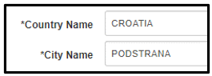

The next thing that would need to be input would be a short detail about what would need to be booked. For simple requests, inputting the reason for the Miscellaneous is sufficient. In cases wherein the client has additional specific requests, this can be added here. There is, however, a 255-character limit for what can be input here.

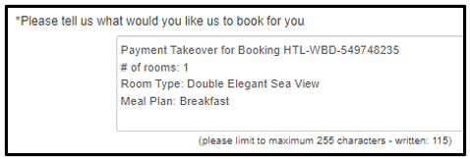

The next that would need to be input the total number of occupants in the booking.

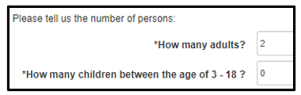

Next thing that will need to be input would be the name of the main guests, our internal reference, as well as for the travel dates for the booking. For Miscellaneous bookings, there is no need to place the names of all guests in the booking. Preferred times may be asked as well, in this area. A user may input N/A for the preferred time.

For the internal reference, the name of the client’s consultant one is working with/requested the Miscellaneous can be input.

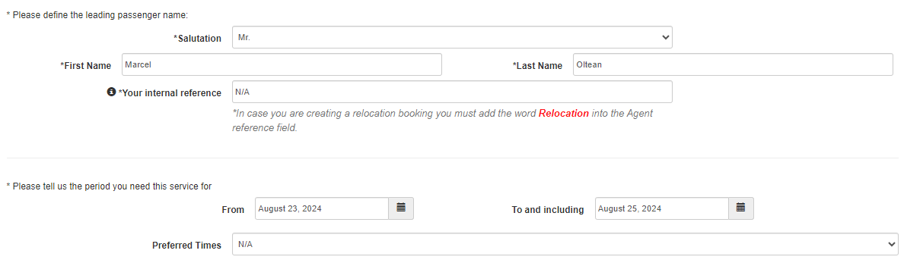

In cases where there is a need to create multiple miscellaneous bookings for a client, clicking on ADD NEW MISCELLANEOUS will allow one to create another MISC in the same screen.
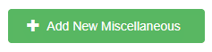

Once all requested information in the page has been input, the WebBeds user can click on the SAVE button.
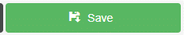

Once the Miscellaneous booking is saved, the page will update and bring to the user to the top-most part of the page. DOTWConnect will present a user a message that the MISC has been successfully added and will show a clickable Miscellaneous Number.

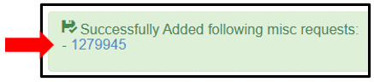

Clicking on this Miscellaneous number will open another tab, wherein a WebBeds user would need to input the supplier and rate information for the miscellaneous being created. The page can be scrolled down, until the PLEASE ATTACH THE SUPPLIER row can be seen.

Once can click on the row to open a pop-up box, which would allow a user to input the name of the supplier for the Miscellaneous.

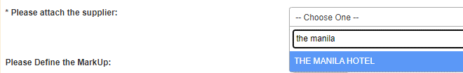

If the name of the hotel/supplier is not in the list, this needs to be raised with your leaders to have the name of the supplier added. If one has access to MISC supplier creation, one may do so, as well.

Once the supplier has been chosen, one will notice that the supplier’s payable currency will automatically to the profiled currency of the hotel/supplier. Unlike previous developments, the payable currency can no longer be changed or modified.

Below the Payable Currency row, one will be asked for the Booking (Supplier) cost and if the rates that will be input in the booking would be Daily rates or Total rates for all nights. Once the tick box is chosen, an additional row will expand, where the net Booking Cost can be entered, inclusive of taxes and fees.

If the booking cost has been input, DOTWConnect will auto-calculate the selling place for the booking, taking into consideration real-time currency conversion and the customer’s profiled mark-up %. Most of the time, this may be different to the amount than what was quoted to the customer. One can adjust the selling price to the amount quoted to the customer by clicking on the MARK UP CALCULATOR.

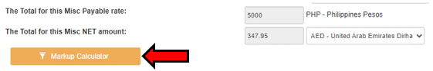

The mark-up calculator would give two options, whether to re-calculate based on a specific mark-up % or based on a specific amount. One would need to choose the appropriate option and adjust the rates, accordingly, based on the information quoted to the client.

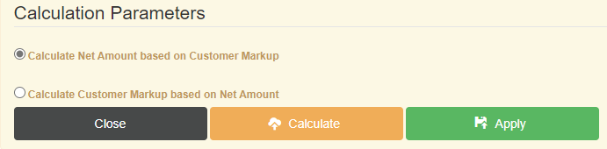

Once adjusted, the orange CALCULATE button and green APPLY button will need to be clicked.

Once the selling price has been adjusted to the amount quoted to the customer, next thing that will be asked would be the cancellation deadline of the MISC booking and the % of the penalty charges once past the cancellation deadline. For this, the penalty charge % would need to be changed to 100.00%.

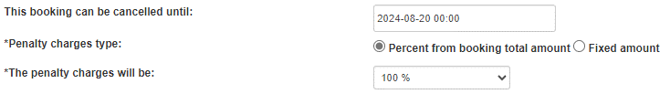

Next thing that will be asked will be the Supplier Reference # for the miscellaneous booking. If the miscellaneous has not be confirmed or accepted by the hotel/supplier yet, this section can be left blank, and user will need to press the SAVE FOR LATER button in the lower part of the page.

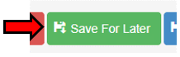

If the supplier has accepted the booking and has given a specific supplier reference or hotel confirmation number, it can be indicated in this row. If the supplier did not give a supplier reference # but accepted the booking on their end, one can just input “Confirmed” in the box, followed by the name and position of the person who accepted the booking in the supplier’s end.

The last thing that needs to be specified would be the Communication Settings for the Miscellaneous booking that you have created. Based on the need of your created booking, a user will be given to adjust:

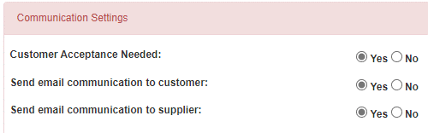

Customer Acceptance needed: choice if the customer would need to “Accept and Reconfirm” a booking once created, otherwise the booking will be auto cancelled. By default, the CS Operations team places this with a “NO,” as the customer has already previously accepted the rates and booking details, prior to the MISC creation.

Send Email Communication to Customer: choice if the customer will be sent a copy of the LPO/Booking Form to the Customer, once the booking is created.

Send Email Communication to Supplier: choice if the supplier will be sent a copy of the LPO/Booking Form to the Supplier, once the booking is created.

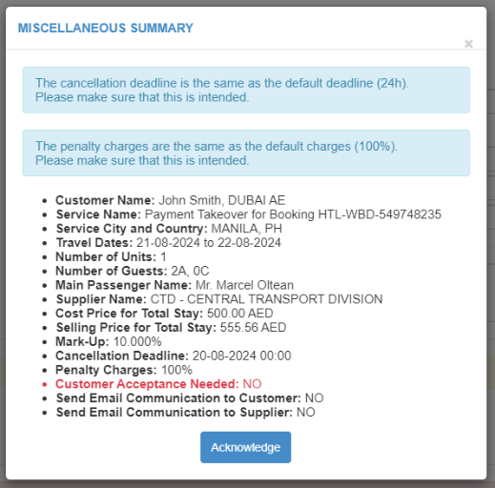
Once everything has been input and confirmed with the supplier, the WebBeds user can click on the CONFIRM MISC button to complete the Miscellaneous booking.

Prior to final confirmation of the booking, the following pop-up box showing the summary of the Miscellaneous created will appear. This will allow the user to fully review the summary of the Miscellaneous booking details – prior to final confirmation.

If all booking details, upon review, is correct, the WebBeds user will need to click on the Acknowledge button to close the pop-up box properly.

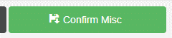
Once the Miscellaneous booking summary has been acknowledged, the user can proceed to click on the Confirm Misc button once more. The page will update with a message saying that the booking has been confirmed.

Further, it will now allow the user to pull out and load the MISC booking in the Central Reservations Office.

